Instructions on Copying Last Year’s Data
OPTION 2 OF 2
You now have the ability to copy last year’s data forward to the new year. Once you’ve copied the data forward, you can manually adjust the records on just those that changed or that you need to add from scratch.
Begin by reviewing tables to ensure relevant data exists. From Personnel > Tables > ACA 1095 Codes, add or edit Offer of Coverage and Safe Harbor tabs as needed.
  - 1095-C Offer of Coverage tab: new codes were added as of calendar year 2020. President Trump’s Executive Order 13813 allows the use of health reimbursement accounts (HRAs) to be funded by employers to reimburse employees for the cost of health insurance coverage purchased in the individual health insurance marketplace. This final rule is applicable to plans beginning in 2020. If your district implemented an HRA, additional codes will need to be added to the Offer of Coverage table. (if you did not implement an HRA, simply ensure the table has the codes you will need (1A – 1H) as in prior years.) New codes are 1J – 1S)

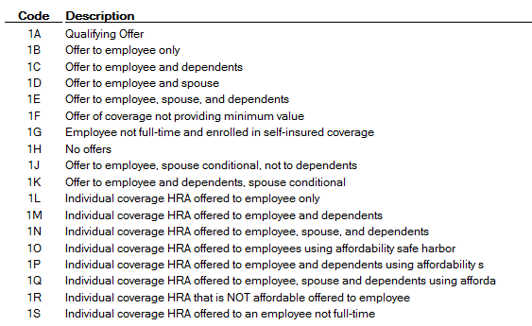

  - 1095-C Safe Harbor tab: no new codes have been added, but each calendar year has its own set of Safe Harbor codes since some have expired. The following codes can be used in 2021:
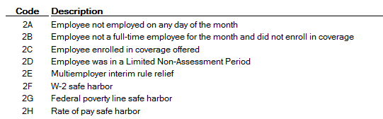

You can now copy data from a prior year. From Personnel > Utilities > Copy 1095 Data, the following options are recommended:
- Extract Option: Delete all existing records and copy all records
- Record Type: ACA 1095-C
- From Calendar Year: 2020
- To Calendar Year: 2021
- Plan Start Month: 09
- Employee Share of Lowest Cost Monthly Premium: This will equal $417.00 – your district & state contribution. For some of you, the district/state contributes $225.00, so your amount will be $192.00. If your district contributes more than that, subtract that amount from $417.00 for the total amount to enter into this field. ASCENDER will automatically use the ‘old’ rate of $161.00 in Jan – Aug, then switch to the ‘new’ rate of $192.00 beginning with the Plan Start Month of Sept.
Execute.
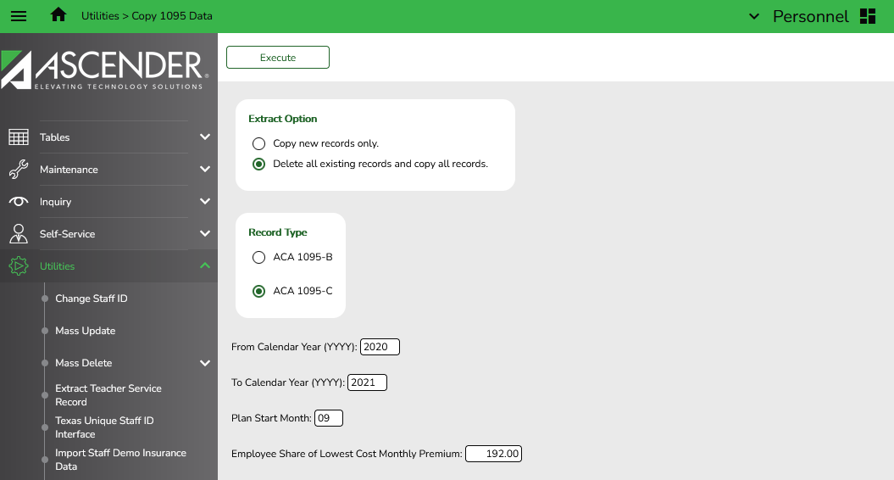
At the preview, review errors. If you have errors listed, make corrections.
You will now need to manually change data for employees whose information differs from last year’s data. From Maintenance > ACA 1095 YTD Data > 1095-C tab, retrieve the desired employee for Calendar Year 2021. If the information has changed since 2020, make the adjustments manually and Save. Common examples would include:
- Adding or deleting coverage for employees or dependents
- Employees who left during the calendar year
- New employees to your district

